**REPORT**

**ON**

**SEXUAL AND GENDER-BASED VIOLENCE (SGBV) BUDGET ANALYSIS IN KENYA: CASE OF THE NATIONAL GOVERNMENT AND SIX COUNTY GOVERNMENTS**

SUBMITTED TO:

**EQUALITY NOW**

BY: STEPHEN OSEDO

*LEAD CONSULTANT*

&

JOHN OCHIENG AND TEAM,

*ASSOCIATE CONSULTANTS*

***© October 2023***

Table of Contents

Acknowledgement – to be done by Equality Now 3

Abbreviations and Acronyms 5

Definition of Terms 6

Executive Summary 7

Study Objectives 12

Why Sexual and Gender Based Violence Budget Analysis? 12

Significance of the Sexual and Gender Based Violence Budget Analysis 13

Methodology 14

Scope of the Study 15

Limitations to Scope of the GBV Budget Analysis 15

Planning and Budget Making Process in Kenya 16

National Level 16

Counties 18

SBV Budget Analysis at the National Level in Kenya 20

Budget Analysis at the County Level in Kenya 22

CIDP Analysis 23

ADP Analysis 27

County Budget Allocation and Absorption Analysis 43

Kajiado County 46

Recommendations 50

Conclusion 52

References 53

# Acknowledgement – to be done by Equality Now

List of Tables and Figures

Table 1: County Planning and Budgeting Calendar 17

Table 2: Budget allocation in State Department for Gender and Affirmative Action; and the National Gender and Equality Commission for FY 2020/21 – FY 2022/23 (KES. Million) 20

Table 3: CIDPII and CIDP III GBV and SGBV programmes 22

Table 4: Funds allocation in county from the FY 2021/2022 26

Table 5: Funds allocation in county from the FY 2022/2023 30

Table 6: Funds allocation in county from the FY 2023/2024 35

Table 7: County Budget Allocation Analysis 40

Table 8: County Budget Absorption Rates 41

Figure 1: Budget formulation by the Kenya National Government 16

Figure 2: County planning and budgeting 16

Figure 3: County Budget Cycle 18

Figure 4: Graphical Representation of Budget Absorption 41

# Abbreviations and Acronyms

ADP Annual Development Plan

CIDPCounty Integrated Development Plan

FGM Female Genital Mutilation

FY Fiscal Year  
GBV Gender Based Violence

GDP Gross Domestic Product

GEF Generation Equality Forum

HIV Human Immunodeficiency Viruses

MDA Ministries Departments and Agencies

NGEC National Gender and Equality Commission

SGBV Sexual and Gender Based Violence

SDGAA State Department of Gender and Affirmative Action

SWG Sector Working Group

USD United States Dollar

# Definition of Terms

**Planning** is the process of making choices, prioritizing, preparing strategies, and allocating limited resources. In other words, making decisions about ‘what is the best way to deliver services to county citizens, based on the available resources the county has?’

**Budgeting**  is the government’s spending plan for the year that is based on the priorities identified in the county’s development plans.

**Implementation** is about the actual ‘doing’ of the activities that are planned and budgeted for—for example, delivering services in health, water and sanitation, and agricultural services at county level.

**Monitoring** is about keeping track of the way that activities are implemented, and reporting on how well these things are done, including how well the money to deliver services has been used.

**Review** means looking at what was done in the past year and identifying what went well, and where to improve for the following year, starting with the next planning process.

**Upstream** in relation to the CIDP is used to explain its linkages with the bigger and longer county plans like the sector plans, the spatial plans, and the governor’s manifesto.

**Downstream** in relation to the CIDP is used to demonstrate its linkages with shorter subsequent county documents like departmental strategic plans, annual development plan, annual budget, and annual work plan.

# Executive Summary

The overall goal of this assignment was to provide an analysis on county and national budgets on prevention and response to SGBV. The outcome was to provide a comparative analysis of the financial commitments made by the national and the county governments of Makueni, Kajiado, Narok, Kisumu, Busia and Kwale thus far on programmes and projects aimed at addressing SGBV. The analysis focused on the period from June 2021 when the Government of Kenya, as co-chair of the Gender-Based Violence (GBV) Action Coalition of the Generation Equality Forum, made commitments to ending GBV, including sexual violence, by 2026.

Through this work, addressing SGBV and other forms of violence against women and girls should become a priority in the national and county development plans at scale. The consultants analyzed the relevant Public Expenditure Management (PEM) documents from the national and the six county governments and hereby present a comprehensive report that will act as a good reference point during discussions on how the authorities allocate resources to the SGBV sub-sector. The output of this work will help address the interlinking “triple threats'' (teenage pregnancy, HIV, and GBV) that have been identified as major barriers to women and girls attaining their full potential and contributing to the country’s Gross Domestic Product (GDP). The recommendations should ensure sustainable investment in the SGBV and GBV sub-sectors, adequate coverage, and sustainably financed social protection systems at both the national and county levels. This will positively impact the lives of 16,926 women and girls SGBV survivors nationally (Kenya Demographic Health Survey 2022 Report).

To develop this comprehensive report on allocation by both the national and the selected six county governments on SGBV and GBV, the consultants adopted a hybrid approach of both desktop research and analytical approach. Relevant planning and budget documents and reports, policy and legislations from the national and selected county governments were reviewed and analyzed to inform key takeaways and recommendations. Initial desktop scoping had focused on the review of policy, legal, and regulatory frameworks on prevention, response and management of GBV, both at the national and the county level. The budget estimates and expenditure reports, supplementary budgets, Sector Working Group (SWG) reports, the Annual Development Plans and the County Integrated Development Plans for the six selected counties were also reviewed.

Preliminary findings of the analysis and recommendations focusing on the national government, and Makueni, Kisumu, Narok, and Busia counties were shared during the GEF-Mid Point Moment on 14th and 15th September 2023 at Safari Park Hotel, Nairobi. The consultants then developed this comprehensive report of the findings, with corresponding priority action steps and recommendations by both levels of government to bring them back on track towards achieving the GEF commitments.

|  |
| --- |
| At the national level, the Study found out that though delivery units and Key outputs remain relatively the same, the Key Performance Indicators (KPIs) varied across years and programmes. Most gender specific programmes, including SGBV and GBV, are domiciled at the State Department for Gender and Affirmative Action which has a policy mandate, while oversight sits with the National Gender and Equality Commission. Budget allocation to gender specific programmes increase during the Kenya Kwanza regime as compared to the Jubilee 2017-2022 Jubilee administration. However, budget allocation to NGEC reduced with the Kenya Kwanza regime. |

Sub nationally, the six selected counties had plans to address SGBV as harmful practice and listed a few GBV- ‘related’ programmes in both CIDP II and CIDP III with some like Makueni, Kisumu, and Kajiado proposing very elaborate programmes to be implemented in the five years. Key highlights of programmes proposed to curb GBV were establishment of GBV recovery centers, training GBV champions, and economic empowerment for survivors. Narok and Kwale counties surprisingly did not consider investing in the fight against FGM as a component of GBV in both CIDPs despite its prevalence in the two regions.

The number of GBV programmes increased significantly in CIDP III compared to CIDP II. Makueni, Kisumu, and Kajiado had the highest number of GBV programmes proposed in CIDP III. Most counties had similar programmes recurring in both CIDP II and CIDP III. This could only mean three things: one, that the GBV programmes in question were a mere copy-paste of the ones previously in CIDP II; two, that there was lack of achievement for the programmes in CIDP II hence the need to reconsider them in CIDP III; and three, that the counties are clueless on other aspects of GBV that could be funded.

None of the counties demonstrated investments in exploring and strengthening GBV-data and evidence ecosystem, considering how critical it is in decision making.

All the counties are not consistent with anchoring gender issues in the county governance structure. Some premise gender in the department of education, and others in sports and culture. On most occasions, the word 'gender' is omitted from the name of the department which is a clear sign that there is lack of deliberateness and intentionality in tackling gender issues, including SGBV and GBV at the devolved units.

Overall gender mainstreaming is prominent in the CIDPs, both in proposed programmes and other generic sections but this remains high level with little attempt to unpack the various aspects of gender like SGBV, GBV, intimate partner violence (IPV), women economic empowerment, women in leadership, male inclusion, etc., and how this plays out in those specific county contexts. While there was some effort to address GBV, none of the six counties considered SGBV as another form of violence affecting women and girls in the society. The six counties would go an extra mile to prioritize some of those programmes in their annual plans (ADPs), but with underwhelming resource allocations when compared with total sectoral and county allocations. Only Kajiado (40% in FY 2023/2024) and Makueni (26% in FY 2021/2022) had reserved more than 10% of the sectoral budget to GBV. Budget absorption rate for planned GBV programmes varied across the counties. While Makueni, Narok, and Kajiado registered absorption rates of over 80% FY 2022/2023, Kisumu managed a paltry 0.4%. Worse still, the budget implementation reports for FY 2022/2023 from the Office of the Controller of Budget show no records of expenditure in the SGBV and GBV sub-sector over the same period, but this could be attributed to the broader classification used by the budget watchdog, or just the ambiguous nature of the financial reports by the county governments. In the FY 2021/2022 Makueni county had the highest allocation of up to 25% of the sector budget allocated to GBV programmes while Kwale had the least allocation of 1.7%. However, in FY 2022/2023, the funds allocation to GBV programmes across the six counties reduced significantly. The trend continued in FY 2023/2024 except in Kisumu and Busia which proposed huge capital projects in GBV infrastructure.

At the time of the analysis, all the counties except Narok and Kwale, had finalized the preparation of their FY 2023/2024 ADP. Apart from Kajiado and Makueni that recorded a reduction in the allocation of funds to GBV programmes of -84%and -53% respectively compared with the previous year, the rest of the counties recorded an increased allocation with Busia boasting 73% and Kisumu 61.5% increase.The funds allocated by the six counties towards addressing GBV have slightly increased from -18% in FY 2021/2022 to 24% in 2023/24. The data shows that the number of programmes and targets has also generally increased over the same period.

There should be consistency in the Key output nomenclature at the national level to make it easy to track implementation of SGBV and GBV commitments at that level. County governments also need to step up their efforts to fight SGBV and GBV through enactment of policy SGBV and GBV policy frameworks that would provide for meaningful programming and resource allocation to the sub-sector. The counties should avoid copy-pasting of programmes from the previous plans. Prioritization should be properly undertaken, and sufficient funds allocated to the programmes. Enhanced coordination between national and county governments to avoid duplication of resources and roles aimed at addressing GBV in the country. Further, there is also need for consistency in the planning and budgeting process from prioritization to budgeting and expenditures for GBV programmes in the counties, and more targeted programmes that are geared towards addressing GBV. Both levels of government need to align gender programmes at the county level with the GEF commitments nationally and globally. For oversight purposes, the public should ensure that they actively and meaningfully participate in the planning and budgeting process (PEM Cycle) to ensure that the programmes are aligned with the priorities and interests of the people.

**Introduction**

Whether sexual, psychological, or physical, Gender-Based Violence (GBV) is defined as any harmful act that is perpetrated against a person and is simply based on differences between males and females {gender}.[1] GBV is a symptom of underlying gender inequalities and power imbalances that transcend the bounds of geography, race, culture, class, and religion, touching virtually every community. It is often condoned by customs and reinforced by institutions.

Post-promulgation of the new Constitution of Kenya in 2010, Kenya has put in place numerous policies, legislative and regulatory framework on response, prevention, and management of GBV both at the national and the county level.

Article 5 and 6 of the Constitution of Kenya provides that the general rules of international law shall form part of the law of Kenya; and any treaty or convention ratified by Kenya shall form part of the law of Kenya under this Constitution. Relatedly, Kenya has ratified several international and regional legal and policy instruments that seek to protect women and young girls against GBV in general and SBGV in particular.

Additionally, Chapter four (4) of the Constitution of Kenya provides for a very elaborate and comprehensive Bill of Rights. Among the provisions of this chapter is Article 28 that provides that “Every person has inherent dignity and the right to have that dignity respected.” Further, Article 29 (c) stipulates that “Every person has the right to freedom and security of the person, which includes the right not to be - (c) subjected to any form of violence from either public or private sources (domestic violence).”

Pursuant to article 59 (4) and (5), the National Assembly enacted the National Gender and Equality Commission Act, 2011 that established the *National Gender and Equality Commission (NGEC)* with, among others, mandate to (a) promote gender equality and freedom from discrimination in accordance with Article 27 of the Constitution; (b) monitor, facilitate and advise on the integration of the principles of equality and freedom from discrimination in all national and county policies, laws, and administrative regulations in all public and private institutions; (c) act as the principal organ of the State in ensuring compliance with all treaties and conventions ratified by Kenya relating to issues of equality and freedom from discrimination and relating to special interest groups including minorities and marginalized persons, women, persons with disabilities, and children; and (d) coordinate and facilitate mainstreaming of issues of gender, persons with disability and other marginalized groups in national development and to advise the Government on all aspects thereof.

In 2014, the Government of Kenya through the then Ministry of Devolution and Planning developed the National Policy for Prevention and Response to Gender Based Violence. In addition, in 2017, the National Gender and Equality Commission developed the model County Government Policy on Sexual and Gender Based Violence to provide overall guidance to the County Governments on critical aspects and considerations for Policy on SGBV. The model Policy was developed alongside the Model Legislative Framework on SGBV. In principle, the model policy was developed to provide a mechanism for coordinating the response to SGBV at the County level.

Although Kenya has done well with respect to ratification, domestication and establishing adequate legal and policy framework on response, prevention, and management of SGBV, available data suggests that SGBV is still highly prevalent in Kenya, with 40.7 per cent of women reported to have experienced physical and sexual violence despite a progressive Constitution and robust and responsive legislative framework in Kenya to address the vice.

To mitigate against this phenomenon, the Government of Kenya, in June 2021, as co-chair of the Gender-Based Violence (GBV) Action Coalition of the Generation Equality Forum, committed to ending GBV, including sexual violence, by 2026. When making the announcement, Kenya promised to intensify its campaign to end these violations by undertaking a series of 12 bold commitments. The commitments included the following, with regards to financing and resourcing:

*(a)* Investing USD 23 million for GBV prevention and response by 2022 and increase the resource allocation up to USD 50 million by 2026 through a co-financing model. Specifically, the Government of Kenya, commits to sustain the allocation for FY2020/2021 of USD 2.79 million to GBV and FGM and incrementally work towards a minimum budget allocation of USD 5million for subsequent financial years. In addition, we commit to institute an accountability framework for tracking expenditure.

*(b)* Invest USD 1 million annually for GBV research, and innovation to boost evidence-based programming by 2026.

*(c)* Establishing a GBV survivors fund - through a co-financing model in partnership with the private sector, civil society, and other stakeholders - for the economic empowerment of GBV survivors.

It is worth noting that when the new government came into power in 2022, it, through the Cabinet resolution re-committed to the 12 commitments in 2023, thus signifying political goodwill to address GBV holistically.

The realization of these commitments can only be progressively realized through deliberate prioritization of budgetary allocations to ensure at all levels the implementation of policies and programmes on response, prevention, and management of SGBV at both the National and County governments. To this end, it is very critical for the State and Non-State actors to deliberately push for increased spending towards the promotion and realization of these 12 commitments.

This report seeks to assess and establish the progress Kenya has made towards financing and resourcing of the gender specific commitments by the national and identified county governments. Ultimately, this report can be used for awareness creation and advocacy for the realization of gender specific commitments aimed at addressing SGBV.

# Study Objectives

The study sought to conduct a review and analysis of budgetary allocations and expenditure on gender and SGBV at the national and six selected counties of Kisumu, Busia, Kwale, Kajiado and Narok. Specifically, the study sought to assess the following:

*(a)* Review and analyze inclusion of programs on gender and SGBV prevention and response in the County Integrated Development Plan (CIDP) II and III, as well as the Annual Development Plans (ADP) over the past three years in Kisumu, Busia, Kwale, Kajiado and Narok Counties.

*(b)* Analyze Budgetary allocations touching on gender and SGBV prevention and response in the annual county budget including the supplementary budgets over the past three years.

*(c)* Analyze Budgetary allocations touching on gender and SGBV prevention and response in the national annual budget including the supplementary budget.

*(d)* Review and analyze Expenditure on gender and SGBV prevention and response in the national and county budgets for the past three (3) years in the six (6) focus counties; and

(e) Provide findings, including gaps/ challenges and recommendations conclusions, based on the review and analysis.

# Why Sexual and Gender Based Violence Budget Analysis?

The study notes that Kenya, as a country, has no shortage of legal and statutory instruments to help in addressing the issues around Sexual and Gender Based Violence (SGBV). This is because Kenya has ratified several international and regional treaties pursuant to article 5 and 6 of the Constitution of Kenya. The report further holds that for the Generation Equality Forum (GEF) commitments to be progressively realized, it would take deliberate effort on the part of the Government to prioritize resource mobilization and allocation towards the implementation of the gender-specific programmes that seeks to address issues on SGBV.

Consequently, this study identifies public budgets as important political and economic instruments of governance that are used for achieving development objectives of the State and they (public budgets) indicate the government’s commitment towards the delivery of government policies agenda for the welfare of the public. It is through the public budgets that the government in power seeks to implement its manifesto programmes. And therefore, the government policy pronouncements can only be examined within the lenses of public budgets as this will help in assessing whether the government is matching up its policy pronouncement and declared public commitment with the allocation and spending of public resources towards the realization of the same over time.

National and County budgets therefore reflect how the two levels of governments mobilize, allocate and spend public resources towards addressing the people's political, social and economic needs. If public budgets fail to reflect and address gender concerns affecting women and girls in Kenya, regardless of the level of government, then the implementation of these gender-specific commitments to which the Kenya Kwanza government of the day re-committed to their realization will remain a mirage.

Additionally, anecdotal evidence suggests that adequate and targeted budgetary allocations and spending in the gender-sub sector allows for effective prevention and response to sexual and gender-based violence by ensuring that there are programs for sensitization, awareness creation, building and equipping safe spaces for survivors. Further, adequate allocations and spending ensures medical and legal services are available and accessible to survivors, and effective investigation and prosecution of cases.

# Significance of the Sexual and Gender Based Violence Budget Analysis

This report will provide the much-required evidence for awareness creation and informing policy advocacy interventions towards addressing SGBV and other forms of violence against women and girls, both at the national and county level. It will also go a long way towards addressing the interlinking “triple threats'' (teenage pregnancy, HIV, and GBV) that have been identified as major barriers to women and girls attaining their full potential and contributing to the country’s Gross Domestic Product (GDP).

Further, the report provides actionable recommendations that if implemented will ensure sustainable public investment in the gender and GBV sub-sectors, adequate coverage and sustainably financed social protection systems at both the national and county levels. Consequently, this will positively impact on the lives of women and girls who are SGBV survivors nationally.

Finally, this report lays foundation for future public financing besides putting a strong case on the need for both levels of governments to prioritize and increase public financing for addressing gender-specific commitments including SGBV at both national and county levels.

***[1]*** *IASC, 2005. Guidelines for Gender-Based Violence Interventions in Humanitarian Settings: Focusing on Prevention and Response to Sexual Violence in Emergencies. (Field Test Version). Geneva: Inter-Agency Steering Committee.*

***[2]*** *GoK 2014. National Policy for prevention and response to Gender Based Violence*

# Methodology

To realize the set objectives, this exercise adopted a hybrid approach of both desktop research and analytical approach. Specifically, relevant planning and budget documents and reports, policy and legislations from the national and selected county governments were reviewed and analyzed to develop actionable findings and recommendations. The budget analysis was preceded by desktop scoping that included, but not limited, to review of policy, legal, and regulatory framework on prevention and response and management of GBV both at the national and the county level.

In addition, the available budget estimates and expenditure reports, supplementary budgets, Sector Working Group (SWG) reports and the County Integrated Development Plans for the six selected Counties were also reviewed to identify county context in addition to priority plans that county governments set out to implement over a period of five years (2018-2022) and 2023-2027. In particular, the following are some of the documents that were reviewed are:

1. *The Constitution of Kenya.*
2. *Public Finance Management Act 2012*
3. *Programme Based Budgets (various issues)*
4. *Budget Review and Outlook Papers (various issues).*
5. *County Supplementary Budgets (various issues).*
6. *Approved County Budgets, (various issues).*
7. *County Budget Implementation Review Reports (Various issues).*
8. *Controller of Budgets Reports(various versions)*
9. *County Integrated Development Plans; and*
10. *County Annual Development Plans (various issues).*

To undertake the analysis, the study identified and isolated programmes that aimed at addressing SGBV issues. In particular, the study endeavored to assess the level of public financing in the SGBV sub sector at both levels of government as a way of assessing the level of the government commitment towards fulfillment of the GEF Commitments by the year 2026.

# Scope of the Study

The study involved undertaking a short-term budgetary research analysis on gender-based violence, including sexual violence at the national level and selected six counties of Kisumu, Busia, Kwale, Kajiado and Narok Counties for the three fiscal years (FY 2020/21 – FY 2023/24).

The study reviewed and analyzed budgeted and the actual spending (subject to availability of data) of programmes aimed addressing the commitments on gender-based violence, including SGBV at the national and the six selected counties.

With respect to the budget and expenditure analysis, the study reviewed recurrent and development public expenditures both at the macro and micro-level. In the case of the national government, the analysis looked at the parent ministries and government agencies where gender-specific programmes would be domiciled. Though the study appreciated that these programmes would ordinarily be cross cutting due the government’s efforts towards gender-mainstreaming in all government agencies, the review of the publicly available budget documents showed that majority of such programmes were found at the State Department of Gender and Affirmative Action (SDGAA); and National Gender and Equality Commission (NGEC).

The analysis focused on the period post June 2021 when the Government of Kenya, as the co-chair of the Gender-Based Violence (GBV) Action Coalition of the Generation Equality Forum, made commitments towards ending GBV, including sexual violence, by the year 2026.

# Limitations to Scope of the GBV Budget Analysis

The study was limited by several challenges, the majority of which were data related. For instance, the study relied on the national and county governments budget data that was publicly available. However, such data was in the form that is not disaggregated to the desired level would have enabled a deep dive analysis in responding comprehensively to the requirements of the Terms of Reference. In particular, the programme-based budgets and the supplementary budgets used in the analysis had data disaggregated up-to the level of the department’s delivery units.

Further, to augment the review and analysis of the data from the annual and supplementary budgets, the study reviewed the data from the Budget Implementation Review Reports produced by the Office of the Controller of Budget, this also revealed that the presentation of the data was only up to the Ministries, Departments and Agencies (MDAs) macro-level.

As a way of mitigating against the challenge of inadequate and/or lack thereof complete data, the study also reviewed the sector reports which were however found lacking in consistency with respect to the data presented in these sector reports.

The other challenge related to this analysis both at the National and County level of government relates to the way the budget information is presented thus making it difficult to undertake a one-on-one comparative analysis. Consequently, it became almost difficult to do trend analysis where some of the disaggregated budget items across years failed to match in other year’s budget documents thus resulting in budget gaps. Besides, the review and analysis showed, in the case of six counties under consideration, that the budget information formats were not uniform across these counties and further, the level of disaggregation varies, not only from one county to another, but also within departments in each of the counties across the years under review, thus making it difficult to isolate gender-specific programmes and projects.

# Planning and Budget Making Process in Kenya

## National Level

Planning at the national level is achieved through the Medium-Term Expenditure Framework (MTEF) which was introduced in Kenya in 1998 and was first implemented in the budget in the financial year 2001/2002 after the failure of the Forward Budget Review Program, the Budget Rationalization Program and the Public Investments Program. The main aims of the Program were to increase fiscal discipline, Political accountability and public participation in financial matters and improve the efficiency of government operations through the introduction of Budget Ceilings, Sector Working Groups and frequent Expenditure Reviews (PER, 2010).

The formulation and preparation of the Budget by the national government involves the development and submission of key documents for approval by Cabinet and Parliament. The process is guided by the budget calendar which stipulates timelines for several key activities to be undertaken in order to finalize the Budget and submit it for approval by 30th April of each financial year. The budget calendar is usually contained in the Treasury circular issued in accordance with Section 36 of the Public Finance Management Act, 2012, providing guidelines on the processes and procedures for preparing the subsequent financial year and the Medium-Term Budget

*Figure 1: Budget formulation by the Kenya National Government*

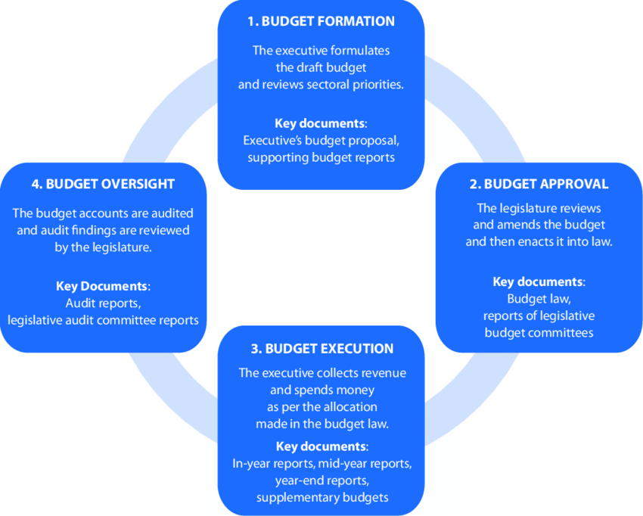

## Counties

*Figure 2: County planning and budgeting*

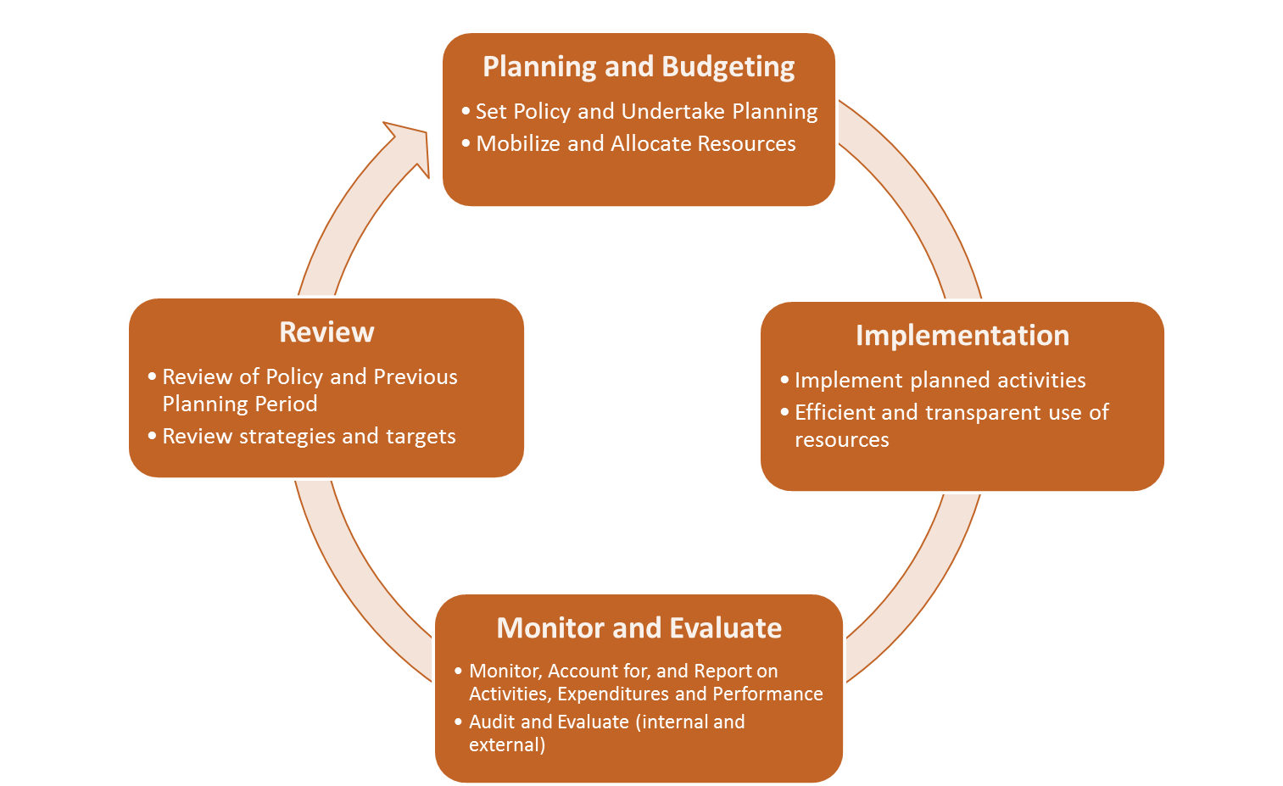

*Table 1: County Planning and Budgeting Calendar*

|  |  |  |
| --- | --- | --- |
| **Timeline** | **Activity** | **Public Participation** |
| Every 5 years | **County Integrated Development Plan (CIDP)** is prepared—a 5-year plan that is a roadmap for development in the county and forms the basis for all county spending in the coming 5 years. | Public can be involved in the plan through SWGs, the CBEF and MCAs; in public forums organized by county administrators at sub-county, ward, village level. |
| 30 August | County Treasury releases a **Budget Circular** to all departments informing them that the budget process is beginning, so they can prepare their requests for funding. | The circular should outline ways the public can be involved in the budget preparation process. |
| 1 September | Counties prepare and table an **Annual Development Plan** (ADP) to the County Assembly for approval. The ADP is drawn from the approved CIDP. | Public forums as above. The plan must be made public within 7 days. |
| 30 September | **County Budget Review and Outlook Paper (C-BROP)** submitted to the CEC. | Public forums as above. After approval, the CBROP should be publicised. |

|  |  |  |
| --- | --- | --- |
| **Timeline** | **Activity** | **Public Participation** |
| **1 January** | Commission on Revenue Allocation (CRA) recommendations on how revenue should be divided between national and county governments. | These recommendations are published by the CRA. |
| **28 February** | County Fiscal Strategy Paper (CFSP) tabled in the County Assembly. | Consultative forums on the CFSP through the CBEF, can be at sub-county levels. Written and oral submissions can be made by the public. |
| **30 April** | County Executive submits Budget Estimates (spending plan) to the County Assembly. | Public can be involved in budget preparation through the SWGs, CBEF and MCAs. |
| **May** | Debate and changes to the proposed budget estimates. | Public consultations on the Budget Estimates take place. |
| **30 June** | Deadline for counties to approve the budget, Finance Bill and Appropriation Bill. End of Financial Year. | Budget to be published and publicised within 21 days after 30 June. |

*Figure 3: County Budget Cycle*

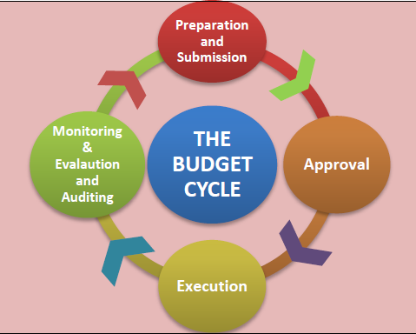

# SBV Budget Analysis at the National Level in Kenya

This section presents the findings of the review and analysis of the public financing for gender-sensitive programmes at the selected institutions within the National Government.

As shown in the table below, the budget allocated to the State Department for Gender and Affirmative Action (SDAA) grew in absolute terms, from Kshs. 3,342.16 million, 620.98 million and 3,945.97 million in FY 2020/21, FY 2021/22 and FY 2022/23, respectively. However, with the transition from the Jubilee administration (2017-2022) to the current Kenya Kwanza regime, the budget of all the programmes (apart from the Gender Mainstreaming) under the SDAA reduced.

The budget for the Gender Mainstreaming Programme whose main objective is to mainstream gender in the government and private sector and promote equitable socio-economic development between men, women, boys and girls increased 13% in FY 2020/21 to 20% in FY 2022/23.

With respect to the oversight National Gender and Equality Commission, the analysis showed that the Commission had only one programme, that is Promotion of Gender Equality and Freedom from Discrimination whose overall objective is to promote gender equality and freedom from discrimination in accordance with article 27 of the Constitution of Kenya 2010 and Vision 2030.

Although, NGEC as an independent Commission pursuant to Chapter 15 of the Constitution of Kenya is protected from any interference (including budget cuts) from the state, the analysis found that despite the renewed commitment by the Kenya Kwanza regime to implement the GEF Commitments, the budget for the oversight Commission (NGEC) was reduced (from Kshs. 449.89 million in FY 2021/22 to Kshs. 408.38 million in FY 2022/23) in the approved budget for FY 2022/23 thus bringing into question whether the Kenya Kwanza regime is really committed to the full implementation of the GEF Commitments specific to Gender financing.

The analysis also found that although the delivery units and Key outputs under each programme remained relatively the same, the Key Performance Indicators (KPIs) varied across years and programmes. In addition, the study also noted that the lack of consistency in the Key output nomenclature made it difficult to track and trace the level of implementation of these GEF commitments.

Table 2: Budget allocation in State Department for Gender and Affirmative Action; and the National Gender and Equality Commission for FY 2020/21 – FY 2022/23 (KES. Million)

|  |  |  |  |  |  |  |
| --- | --- | --- | --- | --- | --- | --- |
| **MDAs** | **FY 2020/21** | **FY 2021/22** | **FY 2022/23** | **FY 2020/21** | **FY 2021/22** | **FY 2022/23** |
| **State Department for Gender and Affirmative Action** | *Budget (KES. Million)* | | | *Programme as a % share of the MDA Budget* | | |
| *P1: Community Development* |  |  |  |  |  |  |
| Affirmative Action | 2,130.00 | 2,185.82 | 2,186.00 | 63.7% | 60.4% | 55.4% |
|  |  |  |  |  |  |  |
| *P2: Gender Empowerment* |  |  |  |  |  |  |
| Gender Mainstreaming | 434.83 | 454.42 | 787.26 | 13.0% | 12.5% | 20.0% |
| Gender and Socio-Economic Empowerment | 511.32 | 667.82 | 663.37 | 15.3% | 18.4% | 16.8% |
|  |  |  |  |  |  |  |
| *P3: General Administration, Planning and Support Services* |  |  |  |  |  |  |
| General Administration and Planning Services | 186.13 | 209.36 | 203.44 | 5.6% | 5.8% | 5.2% |
| Gender County and Sub County Activities | 79.89 | 103.55 | 105.90 | 2.4% | 2.9% | 2.7% |
|  | **3,342.16** | **3,620.98** | **3,945.97** | **100.0%** | **100.0%** | **100.0%** |
|  | *-* | *8.3%* | *9.0%* |  |  |  |
| **National Gender and Equality Commission** |  |  |  |  |  |  |
| *P1: Promotion of Gender Equality and Freedom from Discrimination* |  |  |  |  |  |  |
| Legal Compliance and Redress | 14.11 | 30.30 | 10.49 | 3.8% | 6.7% | 2.6% |
| Mainstreaming and Coordination | 10.82 | 10.84 | 19.66 | 2.9% | 2.4% | 4.8% |
| Public Education, Advocacy and Research | 12.64 | 26.77 | 13.36 | 3.4% | 5.9% | 3.3% |
| General Administration Planning and Support Services | 337.32 | 381.98 | 364.86 | 90.0% | 84.9% | 89.3% |
|  | **374.89** | **449.89** | **408.38** | **100.0%** | 100.0% | 100.0% |
|  | *-* | *20%* | *-9.2%* |  |  |  |

# Budget Analysis at the County Level in Kenya

This section presents findings of a review of how the county governments of Makueni, Narok, Kajiado, Kisumu, Busia, and Kwale have committed to addressing SGBV and other forms of violence against women and girls through resource allocation to related programmes and projects. The review, which focused on the relevant Public Expenditure Management (PEM) documents from the six counties, teased out and tracked investments in sectors that address SGBV from 2021 when the Government of Kenya, as co-chair of the Gender-Based Violence (GBV) Action Coalition of the Generation Equality Forum, made commitments to ending GBV, including sexual violence, by 2026. The analysis builds on preliminary work that was shared during the GEF Mid-point CSO Convening held from 14th to 15th September at Safari Park Hotel in Nairobi in 2023 and incorporates useful insights and feedback from Equality Now and other stakeholders present.

The PEM documents reviewed include the second and third generations County Integrated Development Plans CIDPs (2018-2022 and 2022-2027), the Annual Development Plans (ADPs) for the financial years 2021/2022, 2022/2023, and 2023/2024, and the most recent county budget implementation reports by the Controller of Budget.

# CIDP Analysis

The County Integrated Development Plan (CIDP) is usually one of the first tasks of a newly elected county government and arguably one of its most critical assignments. It is the core five-year development plan that integrates the long-term spatial, sector and urban plans with inputs from the Governor’s manifesto, national government plans and programs, past county development performance and the views and expectations of other development actors and the public at large. The CIDP sets the priorities and guides all county government spending until the next elections. Upstream, it has linkages to the National Vision 2030, county long-term strategic plan, spatial plan, sector plans, urban plan(s), governor’s manifesto, and past CIDP review where applicable. Downstream, the CIDP should speak to the departmental strategic plans, annual development plan (ADP), annual budget, and annual work plan. It is therefore important to underscore the criticality of the CIDP in setting the SGBV agenda as a county priority to allow the counties to allocate resources in its fight as required by the PFM Act 2012.

*Table 3: CIDPII and CIDP III GBV and SGBV programmes*

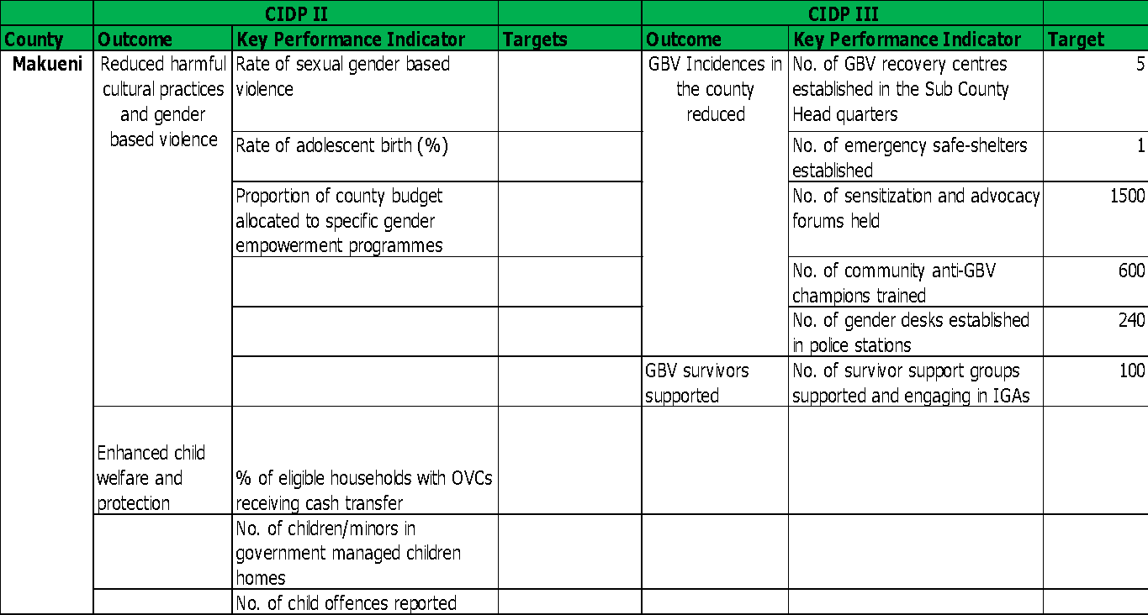

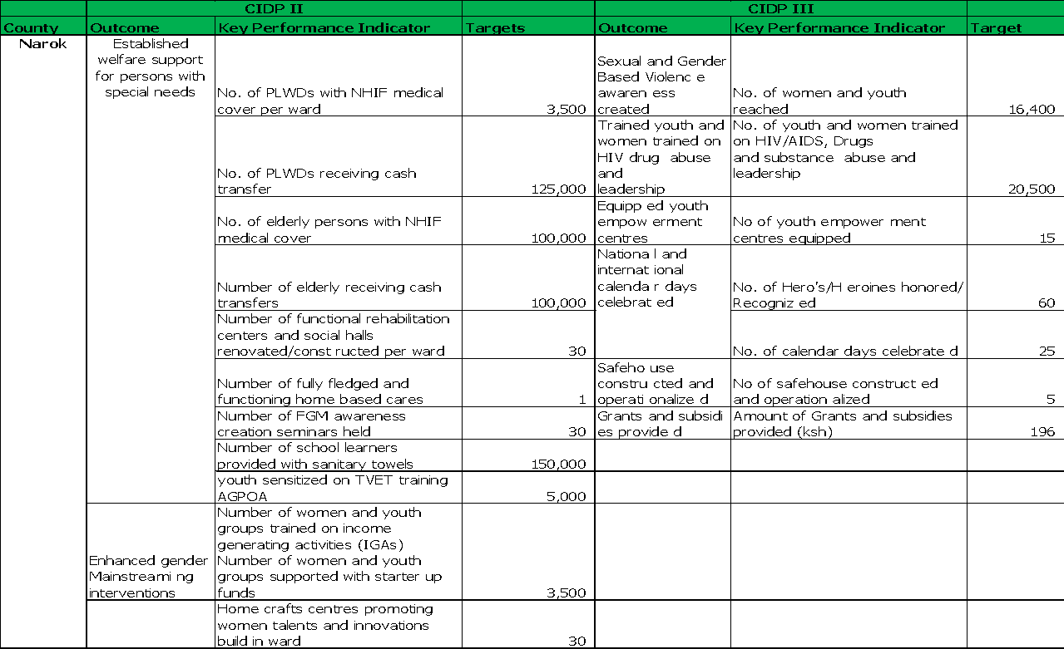

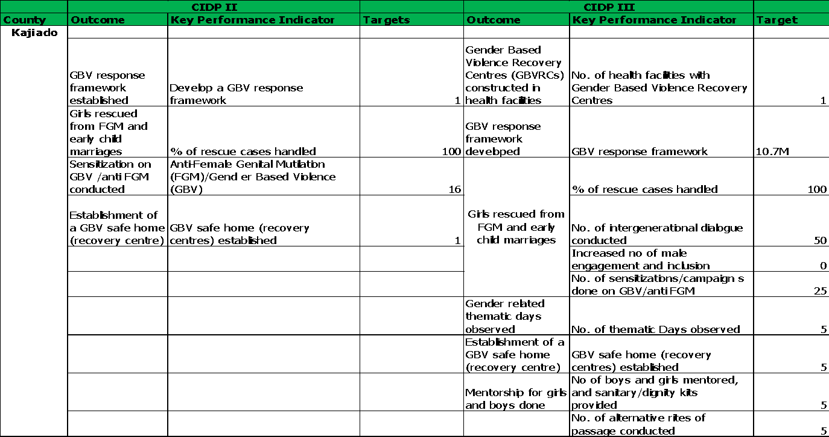

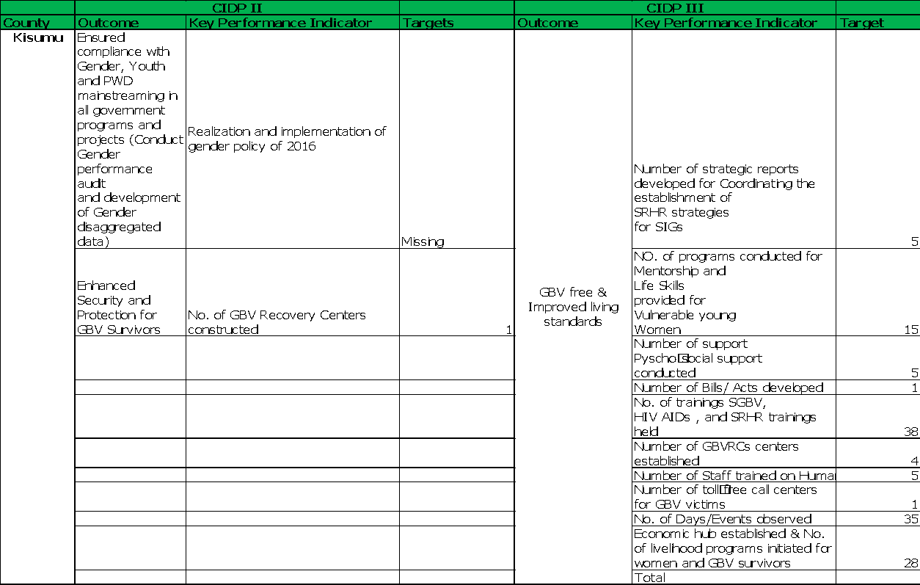

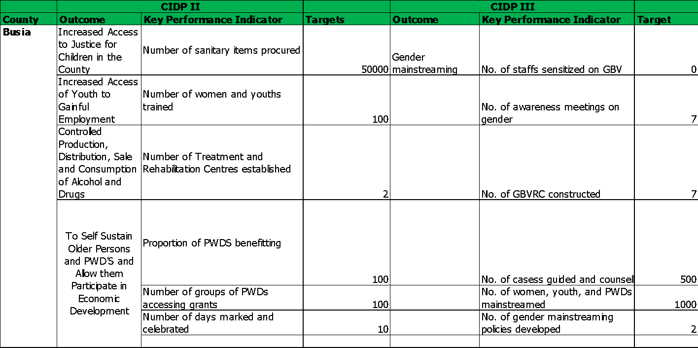

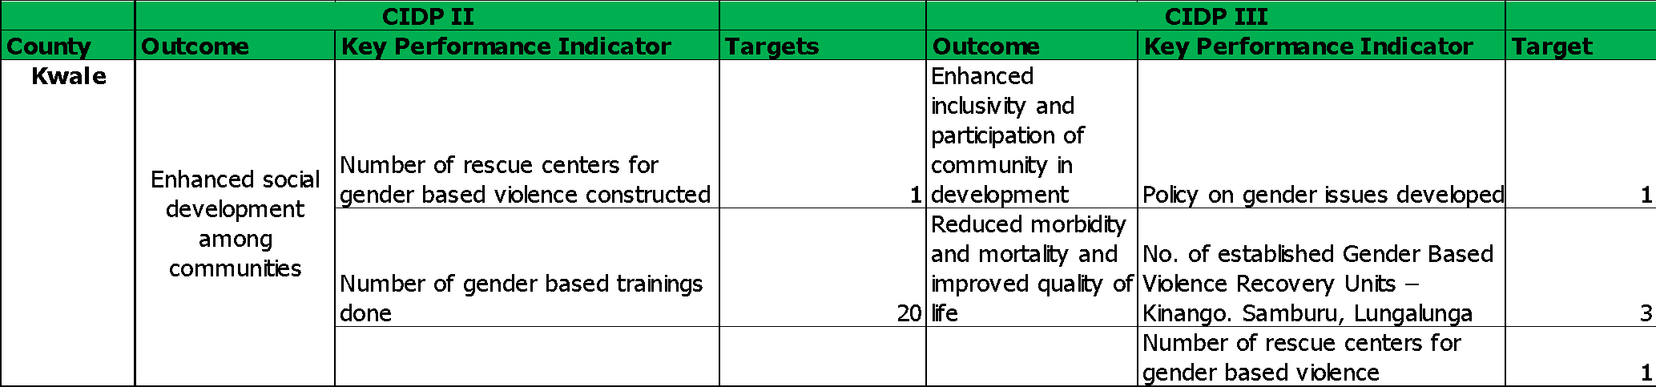

All the counties listed a few GBV- ‘related’ programmes in both CIDP II and CIDP III with some, like Makueni, Kisumu, and Kajiado, proposing very elaborate programmes to be implemented in the five years. Key highlights for Makueni in both CIDPs were programmes to reduce harmful cultural practices and gender-based violence through the establishment of GBV recovery centers, training GBV champions, and cushioning survivors with placements in income generating activities. Kisumu county prioritized enhancing security and protection for GBV survivors through mentorship and life skills training for vulnerable young women, establishing GBV safe centers, a toll-free call center, and an economic hub to support livelihood programs initiated for women and GBV survivors. Kajiado made plans to reduce GBV threats by establishing an unspecified GBV response framework, rescuing girls from FGM and early marriages, conducting sensitization against GBV and FGM, and constructing safe homes for victims. Narok and Kwale counties surprisingly did not consider investing in the fight against FGM as a component of GBV in both CIDPs despite its prevalence in the two regions. Makueni County did not include targets for GBV related programmes in CIDP II, while Kisumu omitted targets for one outcome. This, however, improved in CIDP III where both counties suggested a complete monitoring plan for all the programmes proposed. The number of programmes and targets also increased significantly in CIDP III compared to CIDP II. Makueni, Kisumu, and Kajiado had the highest number of GBV programmes proposed in CIDP III. Most counties had similar programmes recurring in both CIDP II and CIDP III. This could only mean three things: one, that the GBV programmes in question were a mere copy-paste of the ones previously in CIDP II; two, that there was lack of achievement for the programmes in CIDP II hence the need to reconsider them in CIDP III; and three, that the counties are clueless on other aspects of GBV that could be funded. None of the counties demonstrated investments in exploring and strengthening GBV-data and evidence ecosystem, considering how critical it is in decision making.

Whether these promising commitments were prioritized by the devolved units in their yearly budget making process and implementation is an interesting perspective that will be unearthed by further review of PEM documents emanating from the CIDP, like the ADP, budget allocations, and spending.

The omission of ‘Gender’ in the names of the county departments by most county governments is an indication of lethargic efforts to mainstream gender and the fight against GBV . Some counties domicile it in the department of education, and some, in culture and social services but this is not consistent across the fiscal years. Whether mentioned or not, however, it is critical to point out that all the six counties recognize gender as a critical cross-cutting issue, alongside climate change. Mainstreaming of gender is therefore prominent in the CIDPs but this remains high level with little attempt to unpack the various aspects of gender like GBV, women economic empowerment, women in leadership, etc., and how this plays out in those specific county contexts. While there was some effort to address GBV, none of the six counties considered SGBV as another form of violence affecting women and girls in the society.

# ADP Analysis

The Annual Development Plan (ADP) sets out the county’s annual development priorities for the forthcoming year. It represents the annual implementation plan for what was approved in the CIDP and is based on implementation progress and experience captured in Quarterly Progress Reports (QPRs) and the Annual Progress Report (APR). It has linkages to the CIDP (ADP is pulled from each column of the CIDP), QPRs, and APR. Besides being a tool for prioritizing what programmes and projects from the yearly columns of the CIDP, the ADP has a section that reviews the performance of the previous ADP though this is limited to the performance of indicators and not the financial absorption rate.

*Table 4: Funds allocation in county from the FY 2021/2022*

|  |  |  |  |  |  |
| --- | --- | --- | --- | --- | --- |
| **County** | **Sub Programme** | **Outcome** | **Key Performance Indicator** | **Planned Target** | **Budget 21/22 (M)** |
| **Narok** | S.P. 5.2: Community  development and  gender and youth  development | Enhanced gender  Mainstreaming interventions | Number of women and youth groups trained  on income generating activities (IGAs)  Number of women and youth groups  supported with starter up funds | 700 | 10 |
| Number of Home crafts centers promoting  women talents and innovations build in  ward | 6 | 30 |
| Proactive citizen in public  programs and development | Number of civic education programs or  barazas held per ward | 2 | 2 |
| **Total Budget** |  |  |  | **74,959,321** |
| **Total Budget for the department** |  |  |  | **1,559,850,000** |
| **Total County Budget** |  |  |  | **13,352,112,888** |
| **% of sector budget** |  |  |  | **4.81%** |
|  | **% of county budget** |  |  |  | **0.56%** |
| **County** | **Sub Programme** | **Outcome** | **Key Performance Indicator** | **Planned Target** | **Budget 21/22 (M)** |
| **Makueni** | Gender-Based Violence Mitigation and gender mainstreaming | Reduction in gender-based violence rates | No. of SGBV campaigns /awareness and education |  |  |
|  |  | No. of safe shelters equipped and operationalized |  |  |
|  |  | Recruitment of a full-time psychologist to run the GBV recovery |  |  |
|  |  | No. of community anti-GBV champions trained |  |  |
|  |  | Developed programme documentary |  |  |
| **Total Budget** |  |  |  | **129,739,090** |
| **Total Departmental Budget-15% of the County Budget** |  |  |  | **501,171,856** |
| **Total County Budget** |  |  |  | **11,022,090,439** |
| **% of sector budget** |  |  |  | **25.89%** |
| **% of county budget** |  |  |  | **1.18%** |
| **County** | **Sub Programme** | **Outcome** | **Key Performance Indicator** | **Planned Target** | **Budget 21/22 (M)** |
| **Kajiado** | Gender Mainstreaming | Policies developed | No. of gender related policies and laws developed | 2 | 3 |
|  | Boys and girls mentored | No. of boys and girls mentored | 1000 | 2 |
|  | Sanitary towels issued to girls | No. of girls issued with sanitary towels | 2500 | 1.5 |
|  | Thematic days observed | No. of thematic days observed | 6 | 4 |
|  | Persons sensitized on GBV | No. of persons sensitized/trained on GBV, FGM, child marriage | 2000 | 5 |
| **Total Budget** |  |  |  | **142,900,000** |
| **Total Sector Budget** |  |  |  | **877,600,000** |
| **County Budget** |  |  |  | **13,657,300,000** |
| **% of sector budget** |  |  |  | **16.28%** |
| **% of county budget** |  |  |  | **1.05%** |
|  |  |  |  |  |
| **County** | **Sub Programme** | **Outcome** | **Key Performance Indicator** | **Planned Target** | **Budget 21/22 (M)** |
| **Kisumu** | Gender & Social Development Personnel (Employment of  Ward Gender & Social  Development  Officers) | Improved personnel | No. of ward Gender & social Development officers employed | 25 | 8.4 |
| Gender and women empowerment (formation, review and dissemination of social protection policies) | Increased inclusion awareness and participation | No. of policies formulated and disseminated | 2 | 3 |
| Social Protection &Welfare | Improved sanitation | No. of beneficiaries of sanitary towels | 2000 | 0 |
| Social Infrastructure Development & Management | Enhanced Security and protection for GBV survivors | 1 rescue center equipped | 1 | 0 |
| Gender and Women empowerment | Enhanced participation in community development | No. of girls mentored | 600 | 0 |
|  |  |  |  |  |
|  |  |  |  |  |
| **Total Budget** |  |  |  | **11,400,000** |
| **Total Sector Budget** |  |  |  | **2,118,000,000** |
| **County Budget** |  |  |  | **13,657,300,000** |
| **% of sector budget** |  |  |  | **0.54%** |
| **% of county budget** |  |  |  | **0.08%** |
| **County** | **Sub Programme** | **Outcome** | **Key Performance Indicator** | **Planned Target** | **Budget 21/22 (M)** |
| **Busia** | Empowerment of women and PWDs in economic development | Missing | Missing | Missing | 5 |
| Social protection equipment | Missing | Missing | Missing | 6 |
|  |  |  |  |  |
|  |  |  |  |  |
|  |  |  |  |  |
| **Total Budget** |  |  |  | **11,000,000** |
| **Total Sector Budget** |  |  |  | **77,000,000** |
| **County Budget** |  |  |  | **2,213,580,000** |
| **% of sector budget** |  |  |  | **14.29%** |
| **% of county budget** |  |  |  | **0.50%** |
| **County** | **Sub Programme** | **Outcome** | **Key Performance Indicator** | **Planned Target** | **Budget 21/22 (M)** |
| **Kwale** | Preventive and Promotive Health Services (Construction  of a female  ward at Vigurungani  Health Centre  in Puma ward) | Improved sanitation, Improved service delivery | Site Minutes, Completion certificates, No. of female ward constructed | 1 | 5.8 |
|  |  |  |  |  |
|  |  |  |  |  |
| **Total Budget** |  |  |  | **5,800,000** |
| **Total Sector Budget** |  |  |  | **344,422,778** |
| **County Budget** |  |  |  | **2,893,526,921** |
| **% of sector budget** |  |  |  | 1.68% |
| **% of county budget** |  |  |  | 0.20% |
|  |  |  |  |  |

*Table 5: Funds allocation in county from the FY 2022/2023*

|  |  |  |  |  |  |
| --- | --- | --- | --- | --- | --- |
| **County** | **Sub Programme** | **Outcome** | **Key Performance Indicator** | **Planned Target** | **Budget 22/23** |
| **Narok** | S.P 5.2: Community Empowerment and Gender and Youth development | Social economic empowerment for women and youth. | Amount of grants disbursed to youth groups |  | 37.1 M |
| Amount of grants disbursed to Women groups |  | 37.1 |
| No. of women linked to modern bead works markets |  | 3000 |
| Training women on effects of FGM awareness | Number of women trained on FGM, Child marriages and HIV &AIDs -Change on behavior on cultural practices |  | 2000 |
| Gender and youth policy | No of youth women and PWDs policies formulated and developed. |  | 2 |
| Awareness creation on sexual and gender-based violence | No of women and youth reached. |  | 2000 |
|  | No of seminars held |  | 30 |
| **Total Budget-Gender** |  |  |  | **47,954,358** |
| **Total Budget for the departments** |  |  |  | **1,463,590,000** |
| **Total County Budget** |  |  |  | **15,664,077,475** |
| **% of sector budget** |  |  |  | **3.28%** |
|  | **% of county budget** |  |  |  | **0.31%** |
| **County** | **Sub Programme** | **Outcome** | **Key Performance Indicator** | **Planned Target** | **Budget 22/23** |
| **Makueni** | Social Protection | Reduced vulnerability | Percentage of vulnerable populations (OVCs, PWD, MARPs and Elderly) accessing county safety nets |  | OVC-4% PWD-5% Elderly-4.2% |
|  | Increased resilience of the vulnerable population. | Number of vulnerable populations who have developed resilience. |  | 900 |
|  | Reduced Gender Based Violence | Number of GBV cases reported |  | 834 |
|  | Enhanced access to healthcare for the elderly person | No. of male anti-GBV champions recruited; |  | 600 |
|  |  | No. of beneficiaries of dignity packs |  | 300 |
|  |  |  |  |  |
| **Total Budget** |  |  |  | **17,419,307** |
| **Total County Budget** |  |  |  | **11,529,598,474** |
|  | **% of county budget** |  |  |  | **0.15%** |
| **County** | **Sub Programme** | **Outcome** | **Key Performance Indicator** |  | **Budget 22/23** |
| **Kajiado** |  |  |  |  |  |
| Gender Mainstreaming | Policies developed | No. of gender related policies and laws developed |  | 2 |
|  | Boys and girls mentored | no. of boys and girls mentored |  | 1000 |
|  | Sanitary towels issued to girls | no. of girls issued with sanitary towels |  | 2500 |
|  | Thematic days observed | no. of thematic days observed |  | 6 |
|  | Persons sensitized on GBV | no. of persons sensitized/trained on GBV, FGM, child marriage |  | 2000 |
| **Total Budget** |  |  |  | **43,839,791** |
| **Total Sector Budget** |  |  |  | **877,600,000** |
| **County Budget** |  |  |  | **10,892,246,515** |
| **% of sector budget** |  |  |  | **5.00%** |
| **% of county budget** |  |  |  | **0.40%** |
| **County** | **Sub Programme** | **Outcome** | **Key Performance Indicator** | **Planned Target** | **Budget 22/23** |
| **Kisumu** | Social Protection &Welfare | Enhanced Integration and inclusion of the vulnerable persons in community development | No. of & type of support systems | 400 | 3 |
| No. of beneficiaries of sanitary towels | 1200 | 4 |
| Gender and Women empowerment | No. of girls mentored | 500 | 2 |
| No. of policies formulated and disseminated | 1 | 2 |
| Documentation of Gender programs. In billboards, shows, media etc. | 1.5M | 1 |
| Number of staff trained on gender and SRHR issues | 50 | 2 |
| No of committees formed for  coordinating gender focal points  activities across sectors | 42 | 2.5 |
| No. of gender mainstreaming committees established & sustained | 1 | 0.5 |
| Gender & Social Development Personnel | No. of sub county gender and social development officers employed | 7 | 4 |
| **Total Budget** |  |  |  | **43,839,791** |
| **Total Sector Budget** |  |  |  | **2,034,800,000** |
| **County Budget** |  |  |  | **10,248,187,000** |
| **% of sector budget** |  |  |  | **2.15%** |
| **% of county budget** |  |  |  | **0.43%** |
| **County** | **Sub Programme** | **Outcome** | **Key Performance Indicator** | **Planned Target** | **Budget 22/23** |
| **Busia** | Infrastructure Development | Missing | Number of maternity wards constructed and in use | 3 | 42 |
| No. of gender sensitive latrines constructed | 2 | 5 |
| Reproductive health, maternal, neonatal, child adolescent health | Missing | % of women of reproductive age receiving Family Planning (FP) services | 60% | 11 |
|  |  |  |  |  |
|  |  |  |  |  |
| **Total Budget** |  |  |  | **58,000,000** |
| **Total Sector Budget** |  |  |  | **613,250,000** |
| **County Budget** |  |  |  | **3,613,890,000** |
| **% of sector budget** |  |  |  | **9.46%** |
| **% of county budget** |  |  |  | **1.60%** |
| **County** | **Sub Programme** | **Outcome** | **Key Performance Indicator** | **Planned Target** | **Budget 22/23** |
| **Kwale** | Maternal and Child health | Reduced Health risk factors, diseases and environmental health risk factors | Number of new or rehabilitated maternity facilities | 4 | 40 |
| Reproductive Health and Family Planning Services | % of facilities with reproductive health and family planning services | 98% | 6 |
| Gender mainstreaming | Enhanced inclusivity and participation of community in development | Number of sensitization forums on gender issues | 60 | 5 |
| Number of gender-based training done | 4 |
| Number of policies on gender issues formulated and approved | 0 | 0 |
| Number of sensitization forums on gender issues | 4 | 3 |
| Girl child affirmative action |  | Number of sanitary towels procured and distributed | 7000 | 10 |
|  |  |  |  |  |
| **Total Budget** |  |  |  | **64,000,000** |
| **County Budget** |  |  |  | **3,766,894,993** |
| **% of county budget** |  |  |  | **1.70%** |
|  |  |  |  |  |

*Table 6: Funds allocation in county from the FY 2023/2024*

|  |  |  |  |  |  |
| --- | --- | --- | --- | --- | --- |
| **County** | **Sub-Program/Projects** | **Outcomes** | **Key Performance Indicators** | **Target 2023/2024** | **Budget** |
| **Makueni** | Sexual and Gender Based Violence Prevention and Mitigation | Reduced Gender Based Violence | % reduction of GBV cases reported | 20% |  |
|  | No. of anti-GBV champions recruited and trained | 1000 |  |
|  | No. of beneficiaries of dignity packs. | 5000 |  |
|  |  | Upgrade emergency safe shelter for GBV survivors | 1 |  |
| **Total Budget** |  |  |  | **10,000,000** |
| **Total Sector Budget** |  |  |  | **350,000,000** |
| **% of sector budget** |  |  |  | **2.86%** |
| **County** | **Sub-Program/Projects** | **Outcomes** | **Key Performance Indicators** | **Target 2023/2024** | **Budget** |
| **Narok** |  |  |  |  |  |
|  |  |  |  |  |
|  |  |  |  |  |
| **County** | **Sub-Program/Projects** | **Outcomes** | **Key Performance Indicators** | **Target 2023/2024** | **Budget** |
| **Kajiado** | Gender mainstreaming | GBV response framework established | No of GBV Framework established | 1 | 0.2 |
|  | Girls rescued from FGM and early child marriages | % rescue cases handled | 100 | 1.2 |
|  |  | No. of sensitizations/campa igns done on GBV/anti FGM | 5 | 0.8 |
|  | Gender related thematic days observed | No. of thematic Days observed | 1 | 2 |
|  | Mentorship for girls and boys done | % of boys and girls mentored, and sanitary/dignity kits provided | 40 | 0.36 |
|  |  | No. of alternative rites of passage conducted | 1 | 1 |
|  | Friendly credit and financial services accessed by women | No. of women supported with low interest loans and trainings held | 1 | 2.4 |
|  | Develop a policy on unpaid care and domestic work | Policy Developed | 1 | 0.8 |
|  | Women economic empowerment policy developed | Policy formulated | 1 | 0.4 |
| **Total Budget** |  |  |  | **9,160,000** |
| **Total Sector Budget** |  |  |  | **22,748,000** |
| **% of sector budget** |  |  |  | **40.27%** |
| **County** | **Sub-Program/Projects** | **Outcomes** | **Key Performance Indicators** | **Target 2023/2024** | **Budget** |
| **Kisumu** | Reproductive Maternal Neonatal Child and Adolescent Health (RMNCAH | Reduction in preventable diseases through improved capacity of preventive and promotive services | % Health Facilities with Family Planning Mix of methods | 100% | 4 |
| Gender and Women empowerment | Enhanced integration and inclusion of the vulnerable persons in community development | No of programs initiated and executed | 35 | 70 |
|
| Construction of GVB survivors’ Safe House (**Capital project**) |  |  | 1 ward | 15 |
| Completion and refurbishment of Tiengre GBVRc / safe house (**capital project**) |  |  | 1 ward | 15 |
| Capacity building of women and Girl’s mentorship, resolution (**capital project**) |  |  | 7 sub-counties | 10 |
| **Total Budget** |  |  |  | **114,000,000.00** |
| **Total County Budget** |  |  |  | **12,742,180,000.00** |
| **% of County Budget** |  |  |  | **0.89%** |
| **County** | **Sub-Program/Projects** | **Outcomes** | **Key Performance Indicators** | **Target 2023/2024** | **Budget** |
| **Busia** | Environmental health | Increased access to preventive and Promotive health services | Proportion of schoolgirls/Women sensitized on menstrual hygiene | 8 | 10 |
| Number of schools sensitized on menstrual hygiene | 15 |
| Proportion of Girls/Women accessing | 16 |
| Infrastructure development at Tier 3 facilities countywide e | Increased Access to Quality Curative and Rehabilitative Services | No. of health facilities with gender sensitive and disability inclusive sanitation blocks | 1 | 150 |
|  |  |  |  |  |
| **Total Budget** |  |  |  | **160,000,000.00** |
| **Total County Budget** |  |  |  | **2,394,000,000.00** |
| **% of County Budget** |  |  |  | **6.68%** |
| County | **Sub-Program/Projects** | **Outcomes** | **Key Performance Indicators** | **Target 2023/2024** | **Budget** |
| **Kwale (ADP Missing)** |  |  |  |  |  |

In the FY 2021/2022 Makueni county had the highest allocation of up to 25% of the sector budget allocated to GBV programmes while Kwale had the least allocation of 1.7%. However, in FY 2022/2023, the funds allocation to GBV programmes across the six counties reduced significantly. The trend continued in FY 2023/2024 except in Kisumu and Busia which proposed huge capital projects in GBV infrastructure.

As at the time of the analysis, all the counties except Narok and Kwale, had finalized the preparation of their FY 2023/2024 ADP. Apart from Kajiado and Makueni that recorded a reduction in the allocation of funds to GBV programmes of -84%and -53% respectively compared with the previous year, the rest of the counties recorded an increased allocation with Busia boasting 73% and Kisumu 61.54% increase.

The funds allocated by the six counties towards addressing GBV have slightly increased from -18% in FY 2021/2022 to 24% in 2023/24. The data shows that the number of programmes and targets has also generally increased over the same period.

# County Budget Allocation and Absorption Analysis

This analysis also encompassed a comprehensive examination of the county's financial landscape, extending beyond mere allocation figures. In addition to scrutinizing the allocation sums for the fiscal years 2021/2022 and 2022/2023, the analysis delved into the county's budget absorption and spending capacity. It aimed to shed light on the county's ability to effectively utilize the resources at its disposal towards addressing SGBV. By contrasting the funds allocated to the county during each fiscal year with the actual expenditures incurred, the analysis provided a nuanced perspective on the county's financial management practices in relation to SGBV. This analysis aimed to show whether the budgets allocated to SGBV are overspent or are underspent by the spending units in the six counties.

Despite the lack of sufficient data in some counties like Busia and Kwale, most counties demonstrated the ability to spend budgets allocated towards addressing GBV and other gender related programmes. From the analysis, most counties recorded high absorption rate with Kajiado, Narok and Makueni counties registering 98%, 97% and 87% budget absorption rate while Kisumu recorded 4% budget absorption rate for the period ending 30th June 2023.

*Table 7: County Budget Allocation Analysis*

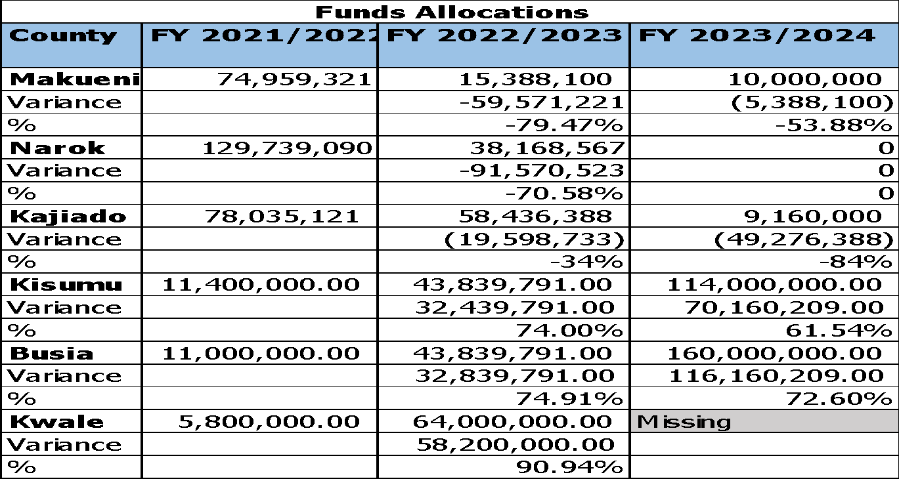

*Table 8: County Budget Absorption Rates*

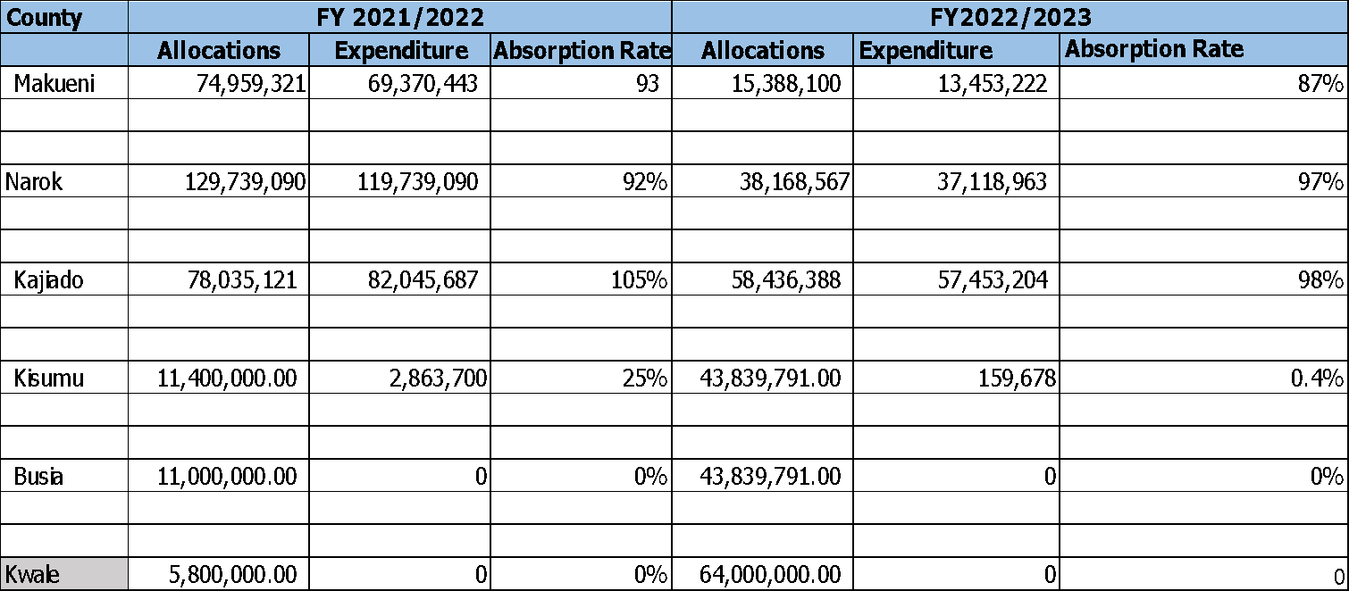

*Figure 4: Graphical Representation of Budget Absorption*

# Kajiado County

The County’s approved budget for the FY 2024/25 is Kshs.12.02 billion which is about 3.8% increase from the budget for the FY 2023/24 comprising Kshs.8.3billion (68.9 per cent) and Kshs.3.6 billion (31.1 per cent) allocation for recurrent and development programmes respectively. The approved budget estimates represented an increase of 3.8% per cent compared to the previous financial year when the approved budget was Kshs.11.56 billion and comprised of Kshs.4.25 billion (36.7 per cent) and Kshs.7.32 billion (63.3 per cent) allocation for development and recurrent programmes respectively.

The Gender, Equity and Empowerment programme under the social protection, culture and recreation sector has been allocated Kshs 56.4M out of the 594.29M total sector budget representing 9.5%. Out of the Kshs56.4M Kshs 26.97M has been allocated to GBV and Anti-FGM related activities representing 47.8% of the total programme budget. This represents a slight increase compared to the FY 2023/24 whereby Kshs 22.74M was allocated to programme out of which Kshs 9.1M was allocated to GBV and Anti-FGM related activities representing 40.2%.

**Comparative Analysis 2023-2024 and 2024-2025**

*Table9: Budgetary allocations for GBV in FY2024/2025*

|  |  |  |  |  |  |
| --- | --- | --- | --- | --- | --- |
| **County** | **Sub-Program/Projects** | **Outcomes** | **Key Performance Indicators** | **Target 2024/2025** | **Budget (M)** |
| **Kajiado** | Gender equity and empowerment | Reduced gender disparities across all levels | GBV response framework developed | 1 | 7 |
|  | Establishment of GBVRC in Health Facilities | No. of health facilities with Gender Based Violence Recovery Centres | 3 | 2.14 |
|  | Intergenerational dialogues on GBV | No. of intergenerational dialogue against GBV conducted | 22 | 1.18 |
|  | Sensitization on GBV and Anti-FGM | No. of sensitizations/campaigns done on GBV/anti FGM | 20 | 0.81 |
|  |  | Celebration of Gender Days. | No. of gender thematic Days observed, No. of pre-activities held before the actual day (16 days of Activism, The Day of the African Child, International Women's Day, Zero tolerance to FGM, international literacy day) | 5 | 8.14 |
|  |  | Mentorship programme for girls and boys | No of boys and girls mentored, and sanitary/dignity kits provided | 20 | 2.36 |
|  |  | Conduct alternative rites | No. of alternative rites of passage conducted | 1 | 3.84 |
|  |  | Awareness meeting on women leadership and participation in peace security and conflict resolution | No of awareness creation meetings held on leadership, decision-making, and participation of women in peace, security and conflict resolution | 4 | 1.5 |
| **Total Budget** |  |  |  |  | **26,970,000** |
| **Total Programme Budget** |  |  |  |  | **56,470,000** |
| **% of the sector** |  |  |  |  | **47.8%** |
| **Total Sector Budget** |  |  |  |  | **594.29M** |

*Table10: Budgetary allocations for GBV in FY2023/2024*

|  |  |  |  |  |  |
| --- | --- | --- | --- | --- | --- |
| **County** | **Sub-Program/Projects** | **Outcomes** | **Key Performance Indicators** | **Target 2023/2024** | **Budget(M)** |
| **Kajiado** | Gender mainstreaming | GBV response framework established | No of GBV Framework established | 1 | 0.2 |
|  | Girls rescued from FGM and early child marriages | % rescue cases handled | 100 | 1.2 |
|  | GBV/Anti-FGM Sensitization/campaigns | No. of sensitizations/campa igns done on GBV/anti FGM | 5 | 0.8 |
|  | Gender related thematic days observed | No. of thematic Days observed | 1 | 2 |
|  | Mentorship for girls and boys done | % of boys and girls mentored, and sanitary/dignity kits provided | 40 | 0.36 |
|  | Conduct alternative rites | No. of alternative rites of passage conducted | 1 | 1 |
|  | Friendly credit and financial services accessed by women | No. of women supported with low interest loans and trainings held | 1 | 2.4 |
|  | Develop a policy on unpaid care and domestic work | Policy Developed | 1 | 0.8 |
|  | Women economic empowerment policy developed | Policy formulated | 1 | 0.4 |
| **Total Budget** |  |  |  | **9,160,000** |
| **Total Sector Budget** |  |  |  | **22,748,000** |
| **% of sector budget** |  |  |  | **40.27%** |
|  | **Total Sector Budget** |  |  |  | **141.2 M** |

*Table 11: Summary of Budgetary Allocation*

|  |  |  |  |  |
| --- | --- | --- | --- | --- |
| **Financial Year** | **2023/24** | **2024/25** | **Variance (-/+)** | **Variance %** |
| **Total Sector Budget** | 141.2 | 594.29 | 453.1 | 76.24 |
| **Total Programme Budget** | 22.75 | 56.47 | 33.72 | 59.71 |
| **Total GBV Budget** | 9.16 | 26.97 | 17.81 | 66.04 |

*Figure 5: Graphical representation of the budgetary allocation for FY 2023/2024 and FY 2024/25*

There was a significant increase in the sector budget in the FY 2024/25 when a total of Kshs 594.29M was allocated out of which Kshs 56.47M was allocated towards Gender, Equity and Empowerment programmes. The increase represents 76.24% compared to the sector budget for the FY 2023/24. The steep increase is a result of Kshs 396M allocated for sports

The GBV budget increased by Kshs 33.7M in FY 2024/25 representing 59.71% compared to FY 2023/24 when the budget was Kshs 22.75M. This was a great improvement as the number of activities also increased significantly.

**Major Achievements in FY 2023/2024**

* + - 1. Vulnerable Groups trained on Financial Literacy, Access to Government Procurement Opportunities (AGPO); Women Enterprise Fund (WEF); and Peacemaking and Conflict Resolution.
      2. Established a Gender-Based Violence (GBV) Framework
      3. Observed Thematic days among them Day of the African Child, International Women's Day, Zero tolerance to FGM and International Literacy Day
      4. Established a GBV safe home in Kajiado Referral Centre
      5. Established 1 GBVRC at Kajiado referral hospital Supported by CCGD
      6. The county conducted 8No. Gender Based Violence (GBV) and anti-Female Genital Mutilation (FGM) sensitization forums and in **turn rescued all girls forced** on Female Genital Mutilation (FGM) and early marriages.
      7. The county also mobilized the public, private sector, organizations and other development partners in observing 16 days of Activism, the Day of the African Child, International Women's Day, Zero tolerance to FGM and International literacy day.
      8. 500 No. of boys and girls were mentored on life skills with girls being provided with dignity kits.

*Table 12: Summary of GBV programmes implementation for FY2023/2024*

|  |  |  |  |  |  |  |  |  |
| --- | --- | --- | --- | --- | --- | --- | --- | --- |
| **Sub**  **program me** | **Key Output** | **Key**  **Performance**  **Indicator (KPI)** | **Baseli ne Data**  **(2018)** | **Planne d**  **Target s /**  **Activit ies** | **Achieve d Targets/ Activitie s**  **Impleme nted** | **Impleme nting agency** | **Source of Funds** | **Remarks** |
| **Programme: Gender Equity and Women Empowerment** | | | | | | | | |
| **Objective: To minimize gender disparities** | | | | | | | | |
| **Outcome: Reduced Gender disparities Across all Levels and Sectors** | | | | | | | | |
| Gender Mainstrea ming | Girls rescued from FGM and early child marriages | % of rescue cases handled | 0 | 100 | 100 | Gender Dept. | CGK/P  artners | Rate of cases reported is very low |
| Sensitization on GBV & anti FGM conducted | No. of sensitizations/ campaigns done on GBV/anti FGM | 0 | 4 | 8 | Gender Dept. | CGK/P  artners | Activities conducted in partnership with WHH, CCGD,Rura l Women Network, Action Aid, Illaramatak community concerns, AMREF,  Plan International  ,World Vision, Malkia Initiative, White ribbon Aliance,  GEM, Hope Beyond, Ptinaai Osim, Red Cross and Population services |
| Gender related thematic days  Observed (16 days of Activism, The Day of the African Child,  International Women's Day, Zero tolerance to FGM, international literacy day,) | No. of thematic Days observed | 1 | 4 | 3 | Gender Dept. | CGK/P  artners |
| Mentorship for girls and boys done | No. of boys and girls mentored, and sanitary/dignity kits provided | 100 | 200 | 500 | Gender Dept. |  |
|  | Establishment of a GBV safe home / recovery Centre | GBV safe home / recovery centres established | 0 | 0 | 0 | Gender Dept. | CGK/P  artners | 1 GBVRC  established at Kajiado referral hospital Supported by CCGD |
| Gender Socio-  Economic Empower ment | Women and youth Enterprise Development Fund (WEDF) rolled out | % of WEDF  disbursed | - | 100 | 50 | Gender Dept. | CGK/P  artners | 50% of the funds not released to the dept  7.5M paid |

# Recommendations

**Standardized** **Key Output Nomenclature:**

National Level: Standardize the key output nomenclature at the national level to facilitate easier tracking of SGBV and GBV commitments and outcomes.

**Enactment of SGBV and GBV Policy** **Frameworks**:

County Governments: Establish and enact specific SGBV and GBV policy frameworks to guide programming and resource allocation towards effectively addressing SGBV at the county level.

**Avoid Copy-Pasting and Prioritize Programs**:

County Governments: Avoid a mere copy-paste of previous GBV programs in CIDPs and instead undertake a comprehensive needs assessment to prioritize initiatives and ensure targeted funding.

**Enhanced Coordination and Resource Allocation**:

Both Levels of Government: Enhance coordination between national and county governments to avoid duplication of resources and roles in addressing GBV. Ensure adequate and consistent funding allocation for GBV programs.

**Consistency in Planning and Budgeting:**

County Governments: Ensure consistency in the planning and budgeting process, from prioritization to budgeting and expenditures, for GBV programs. Align these processes with national commitments.

**Public Participation in the PEM Cycle:**

Public Involvement: Encourage and facilitate active and meaningful public participation in the Planning and Expenditure Management (PEM) cycle to align programs with the priorities and interests of the people.

**Data and Evidence Ecosystem Strengthening:**

County Governments: Invest in exploring and strengthening the GBV-data and evidence ecosystem to inform decision-making and improve the effectiveness of GBV programs.

**Mainstreaming Gender Issues and SGBV Awareness**:

County Governments: Ensure consistent gender mainstreaming and SGBV awareness across various departments and sectors by incorporating it in the county governance structure deliberately and with intentionality.

**Empowerment and Economic Opportunities for Survivors**:

County Governments: Prioritize economic empowerment and provision of opportunities for survivors of GBV, including training and support for their recovery.

**Combat FGM as a Component of GBV:**

Counties: Recognize and address FGM as a critical component of GBV and invest resources to combat it effectively within the counties.

**Improved Budget Transparency and Expenditure Reporting:**

County Governments: Enhance transparency in budget reporting, specifically regarding SGBV and GBV sub-sectors, to provide clear records of expenditure and ensure accountability.

**Alignment with GEF Commitments:**

Both Levels of Government: Align gender programs at the county level with the Generation Equality Forum (GEF) commitments both nationally and globally to ensure coherence and progress towards set goals.

These recommendations aim to address the challenges identified in the report and work towards more effective prevention and response to SGBV, ultimately contributing to the overall well-being and empowerment of women and girls in Kenya

# Conclusion

To address the high prevalence of SGBV across the country where 16,926 women and girls have been violated (Kenya Demographic Health Survey 2022 Report), the Kenya government as co-chair of the Gender-Based Violence (GBV) Action Coalition of the Generation Equality Forum, made commitments to ending GBV, including sexual violence, by 2026. Realizing these commitments require adequate resources and therefore, governments, both at the national and sub-national levels were required to consider adequate budget allocation for the fight against SGBV and GBV threats. This assignment was therefore, aimed at examining the extent to which both levels of government planned for, invested, and expended resources in the sub-sector.

The analysis, which focused on key planning and budgeting documents at both levels, laid bare mixed results on how different governing authorities prioritize SGBV and GBV programming. At the national level, the analysis concluded that although Kenya has made tremendous progress when it comes to putting in place adequate legal and policy framework that supports prevention and response to Sexual and Gender Based Violence the implementation of these policies is still lacking as evidenced by the level of resource allocation to the gender-specific commitments.

The six selected county governments demonstrated good intent to address GBV in their five-year mega plans (CIDPs II and CIDPs III), listing common programme areas to cushion GBV survivors that included establishment of rescue and recovery centers, economic empowerment, and sensitization on harmful cultural practices. The six counties would go an extra mile to prioritize some of those programmes in their annual plans (ADPs), but with underwhelming resource allocations when compared with total sectoral and county allocations. Only Kajiado (40% in FY 2023/2024) and Makueni (26% in FY 2021/2022) had reserved more than 10% of the sectoral budget to GBV. Budget absorption rate for planned GBV programmes varied across the counties. While Makueni, Narok, and Kajiado registered absorption rates of over 80% FY 2022/2023, Kisumu managed a paltry 0.4%. Worse still, the budget implementation reports for FY 2022/2023 from the Office of the Controller of Budget show no records of expenditure in SGBV and GBV sub-sector over the same period, but this could be attributed to the broader classification used by the budget watchdog, or just the ambiguous nature of the financial reports by the county governments.

# References

*County Government of Busia (2018). County Integrated Development Plan 2018 – 2022*

*County Government of Busia (2023). County Integrated Development Plan 2023 – 2027*

*County Government of Kajiado (2018). County Integrated Development Plan 2018 – 2022*

*County Government of Kajiado (2023). County Integrated Development Plan 2023 – 2027*

*County Government of Kisumu (2018). County Integrated Development Plan 2018 – 2022*

*County Government of Kisumu (2023). County Integrated Development Plan 2023 – 2027*

*County Government of Kwale (2018). County Integrated Development Plan 2018 – 2022*

*County Government of Kwale (2023). County Integrated Development Plan 2023 – 2027*

*County Government of Makueni (2018). County Integrated Development Plan 2018 – 2022*

*County Government of Makueni (2023). County Integrated Development Plan 2023 – 2027*

*County Government of Narok (2018). County Integrated Development Plan 2018 – 2022*

*County Government of Narok (2023). County Integrated Development Plan 2023 – 2027*

*Government of Kenya (2011). The National Gender and Equality Commission Act, 2011. The Government Printer, Nairobi.*

*Institute of Economic Affairs (2015). Child Budget Analysis in Kenya; National Government and Six County Governments. Institute of Economic Affairs, Nairobi.*

*National Council for Population and Development (2012). Policy Brief on Sexual and Gender Based Violence in Kenya: A Call for Action. National Council for Population and Development, Nairobi.*

*Republic of Kenya (2007). Kenya Vision 2030. Ministry of Planning and National Development. The Government Printer, Nairobi*

*Republic of Kenya (2010). Constitution of Kenya, 2010. Nairobi: The Government Printer*

*Republic of Kenya (2014). National Policy for Prevention and Response to Gender Based Violence, 2014. Nairobi: The Government Printer*

*Republic of Kenya (2021). Annual County Governments Budget Implementation Review Report for the FY 2020/21. Office of the Controller of Budget, Nairobi*

*Republic of Kenya (2021). Estimates of Recurrent and Development Expenditure of the Government of Kenya for FY 2020/21. The Government Printer, Nairobi.*

*Republic of Kenya (2022). Annual County Governments Budget Implementation Review Report for FY 2021/22. Office of the Controller of Budget, Nairobi*

*Republic of Kenya (2022). Estimates of Recurrent and Development Expenditure of the Government of Kenya for FY 2021/22. The Government Printer, Nairobi.*

*Republic of Kenya (2023). Annual County Governments Budget Implementation Review Report for FY 2022/23. Office of the Controller of Budget, Nairobi*

*Republic of Kenya (2023). Estimates of Recurrent and Development Expenditure of the Government of Kenya for FY 2022/23. The Government Printer, Nairobi.*

*The National Gender and Equality Commission (2016). The Status of Sexual and Gender Based Violence (SGBV) Policies and Laws in Kenya. NGEC, Nairobi.*

*The National Gender and Equality Commission (2017). The County Government Model Policy on Sexual and Gender Based Violence. NGEC, Nairobi.*